**PORTFOLIO**

**COMPUTER SCIENCE AND ENGINEERING**

Submitted by:

Name: Siddhant Gupta

Registration number:12406619

Section: K24CT

Roll No.: 37

**Submitted to: Dr. Joshva Raj G.**



**LOVELY PROFESSIONAL UNIVERSITY**

**DECLARATION**

I, Siddhant Gupta, a student of Bachelor of Technology under CSE discipline at Lovely Professional University, Punjab, hereby declare that all the information furnished in this project report is based on my own work and is genuine

Siddhant Gupta

Registrartion Number: 12406619

|  |  |  |
| --- | --- | --- |
| Platforms for profile creation | Link to student profile | Screenshot |
| ***Quora*** | https://www.quora.com/profile/Siddhant-Gupta-541 | 1 |
| ***Hacker Rank*** | https://www.hackerrank.com/profile/siddhantgupta211 | 1 |
| ***Hacker Earth*** | https://www.hackerearth.com/@siddhantgupta1975/ | 1 |
| ***Geeks for Geeks*** | https://www.geeksforgeeks.org/user/siddhantgwgbv/ | 1 |
| ***LinkedIn*** | https://www.linkedin.com/in/siddhant-gupta-a31281304/ | 1 |
| ***Github*** | https://github.com/Siddhant21-tech | 1 |

2.QUORA

PROFILE:

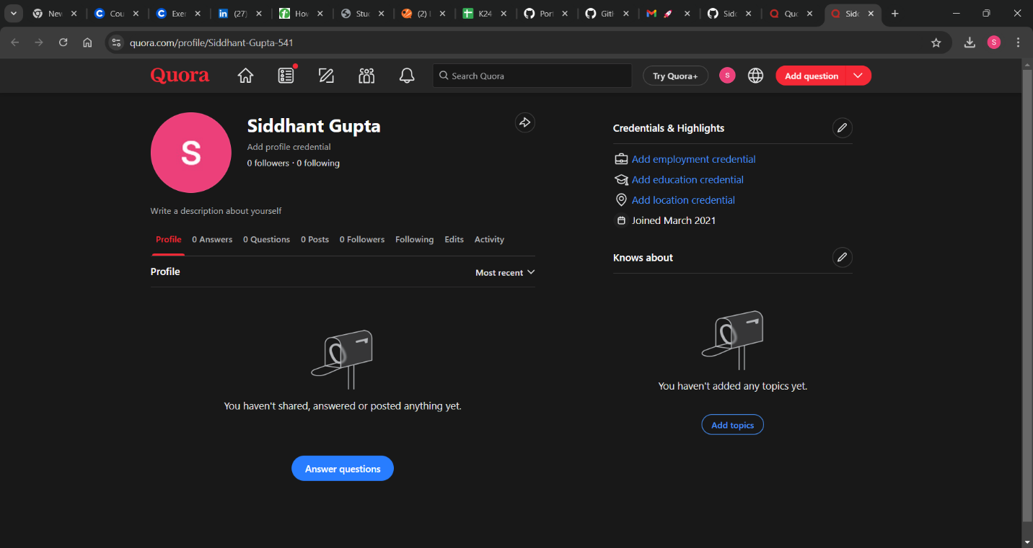

**4.HACKER RANK**

**Profile:**



**5.HACKER EARTH**

**Profile:**

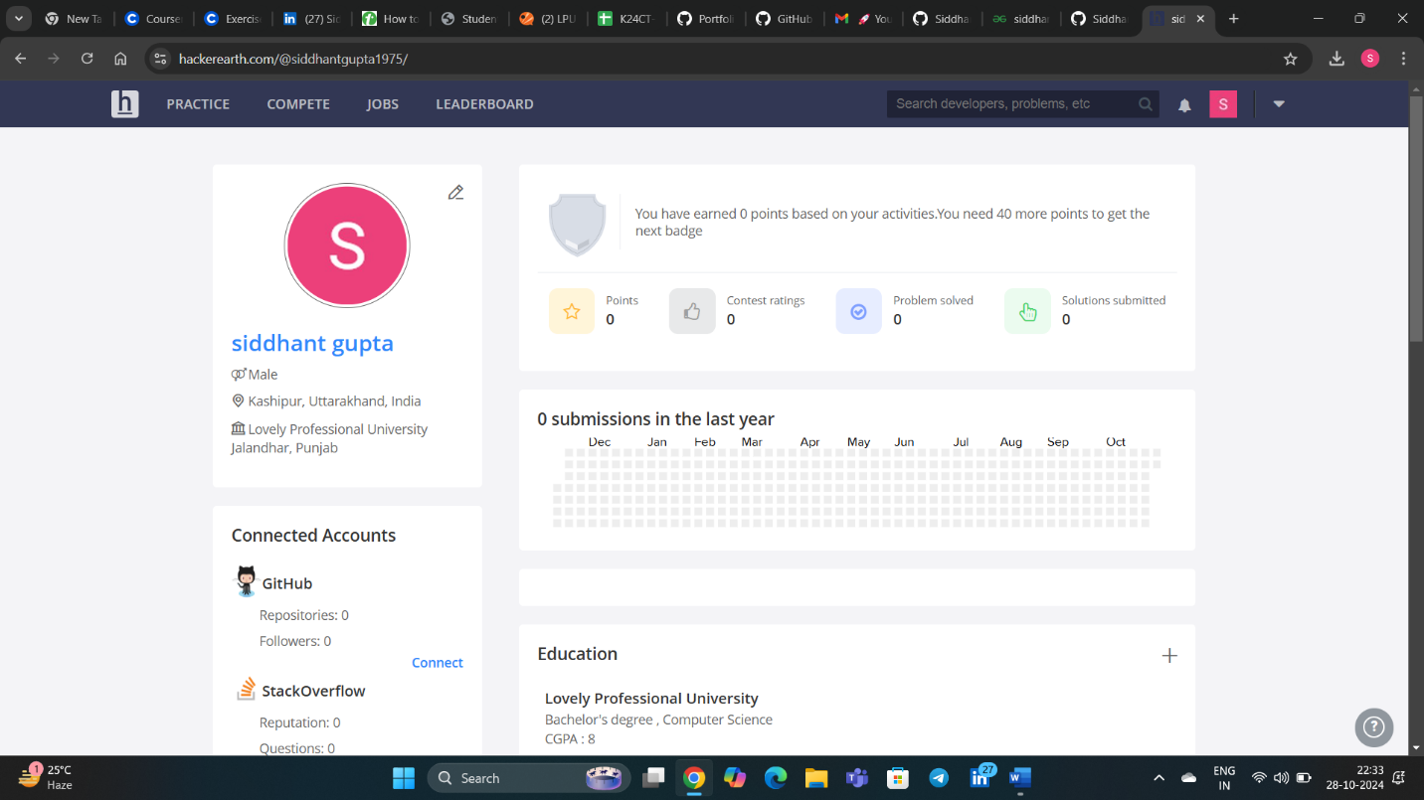

**6.GEEKS FOR GEEKS**

**Profile:**

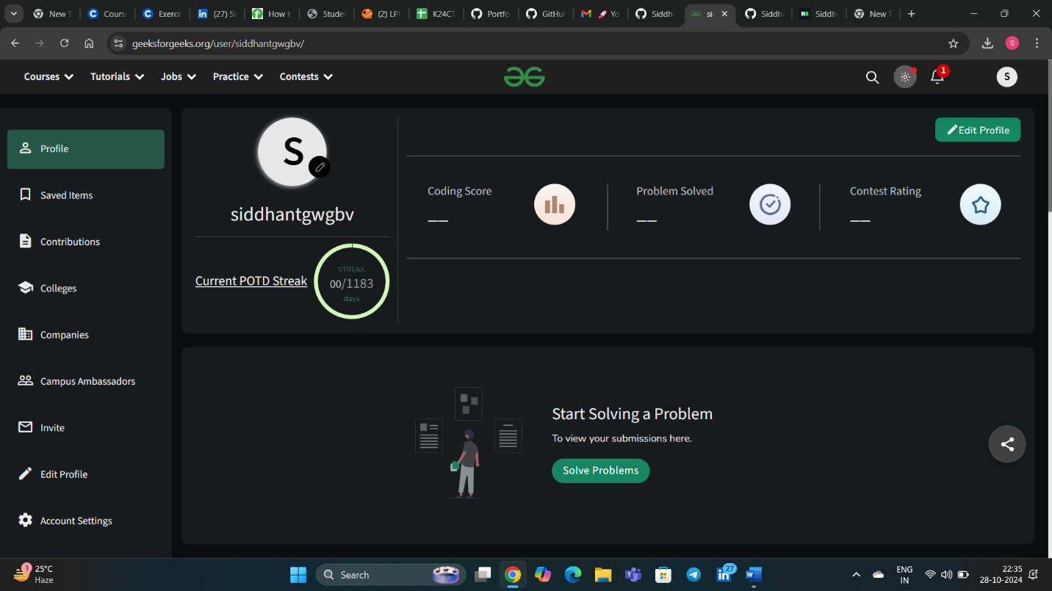

**8. GITHUB**

**Profile:**

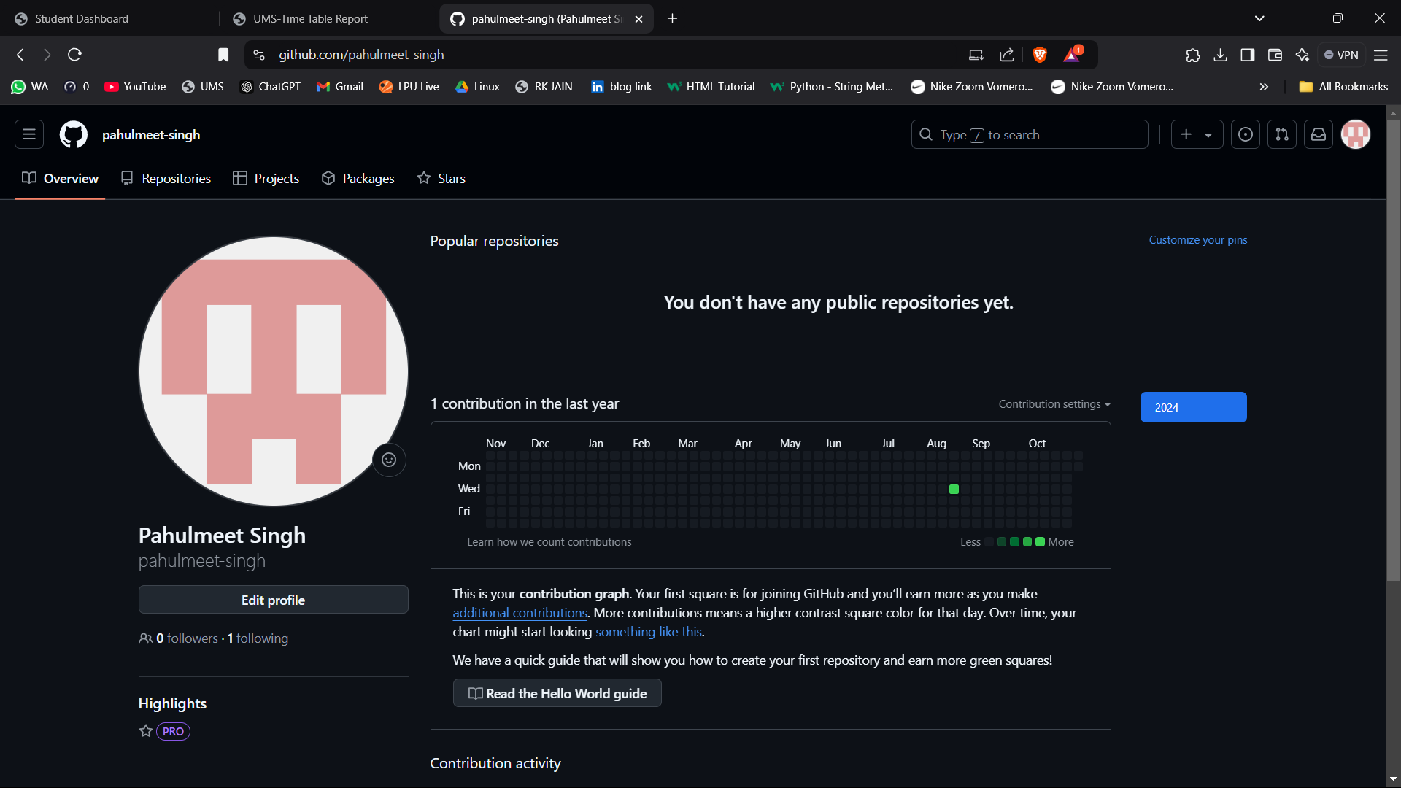

**10.LinkedIn**

**Profile:**

